1. Regular Functions
Definition: The most basic type of function that performs a specific task when called.
Why we need it:
- To organize code into reusable blocks
- To avoid code duplication
- To make code more readable and maintainable
Where to use:
- For any repetitive task in your program
- When you need to perform the same operation multiple times
- As building blocks for more complex programs
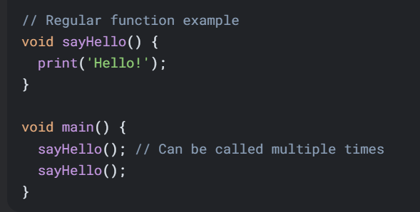

2. Functions with Parameters
Definition: Functions that accept input values (parameters) to customize their behavior.
Why we need it:
- To make functions more flexible and reusable
- To pass different data to the same function logic
- To create more dynamic behavior
Where to use:
- When you need similar operations on different data
- For calculations that require input values
- When processing user input or external data
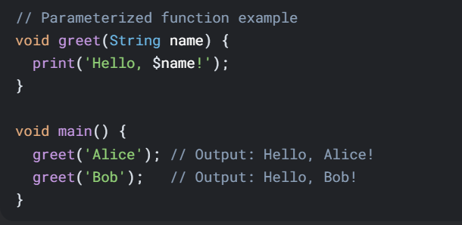

3. Arrow Functions (=>)
Definition: A shorthand syntax for functions that contain a single expression.
Why we need it:
- For more concise code
- When the function body is very simple
- To improve readability for simple operations
Where to use:
- Short one-line functions
- Callbacks and simple transformations
- In functional programming patterns
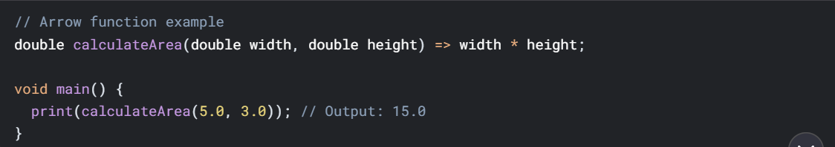
4. Functions with Optional Parameters
Definition: Functions that can be called with some parameters omitted.
Why we need it:
- To provide default behavior when some values aren't specified
- To make function calls more flexible
- To maintain backward compatibility
Where to use:
- When some parameters have sensible defaults
- In APIs where not all parameters are always needed
- For configuration options
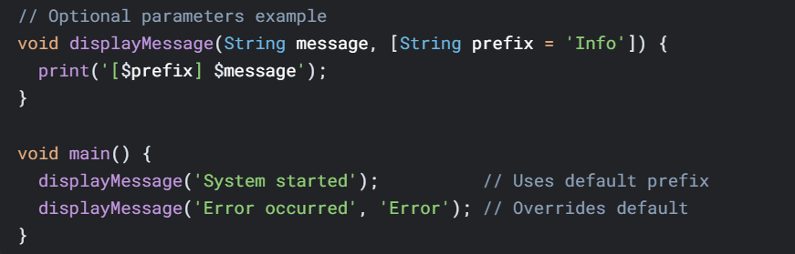

5. Named Parameters
Definition: Parameters that are specified by name when calling the function.
Why we need it:
- To make function calls more readable
- To allow parameters to be passed in any order
- For functions with many optional parameters
Where to use:
- When a function has multiple optional parameters
- For configuration objects
- In APIs where parameter order might be confusing
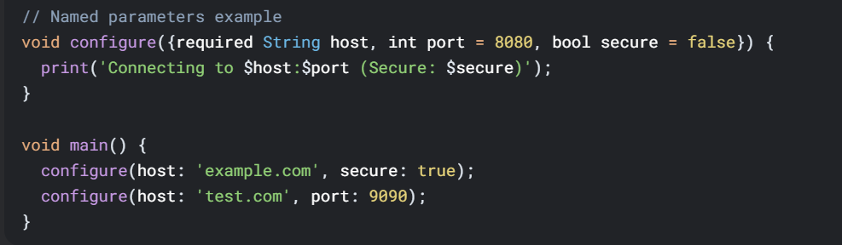

6. Return Values
Definition: Functions that compute and return a result to the caller.
Why we need it:
- To get results from computations
- To enable function composition
- To pass data between different parts of the program
Where to use:
- For calculations and data transformations
- When you need to use the result elsewhere
- In mathematical operations
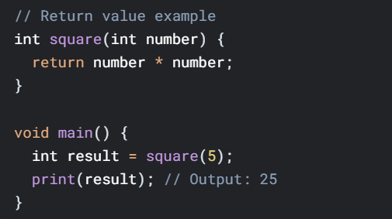

7. Implicit Return Type
Definition: When the return type is inferred by Dart from the function body.
Why we need it:
- For more concise code
- When the return type is obvious
- To reduce boilerplate
Where to use:
- In simple functions with obvious return types
- When prototyping
- In local helper functions
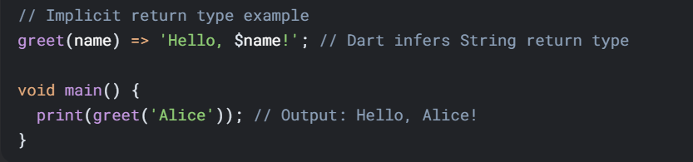

8. No Return Value (Void)
Definition: Functions that don't return any value.
Why we need it:
- For operations that perform actions rather than computations
- When the function's purpose is to produce side effects
- For procedures that don't need to communicate results
Where to use:
- For I/O operations
- When modifying object state
- For logging and printing
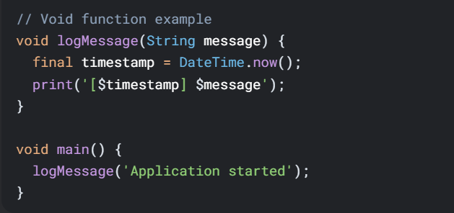

9. Higher-Order Functions
Definition: Functions that take other functions as parameters or return functions.
Why we need it:
- To enable functional programming patterns
- For creating abstractions over behavior
- To implement callbacks and event handlers
Where to use:
- In collection operations (map, filter, reduce)
- For asynchronous programming
- In strategy pattern implementations
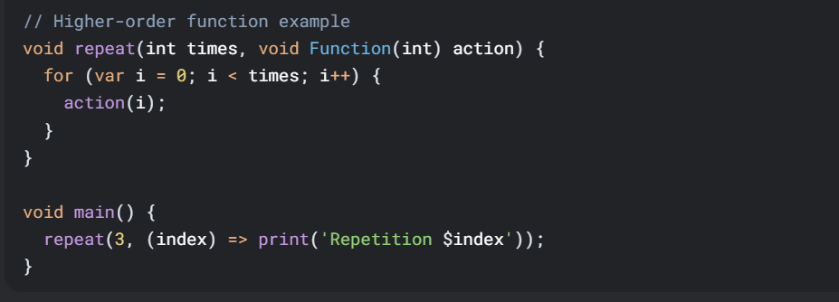

10. Lexical Closures
Definition: Functions that capture variables from their surrounding scope.
Why we need it:
- To maintain state between function calls
- To create function factories
- For implementing callbacks with context
Where to use:
- In event handlers
- For creating specialized functions
- In stateful function patterns
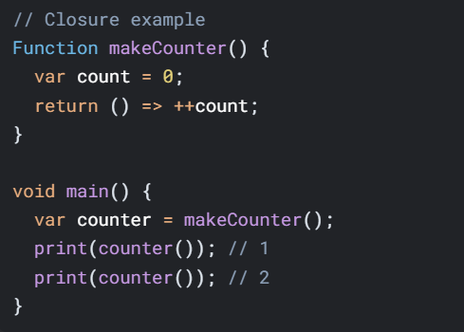

11. Generators
Definition: Functions that produce a sequence of values lazily.
Why we need it:
- For memory-efficient iteration
- To work with potentially infinite sequences
- For lazy evaluation
Where to use:
- When processing large datasets
- For mathematical sequences
- In stream-like data processing
